Time Series and Business Performance Analysis of Global Ecommerce Sales

Contents
- Introduction and Report Objectives
- Dataset and Methodology
- KPI Overview
- Sales and Revenue Analysis
- Profitability Analysis
- Customer Segmentation
- Regional and Market Analysis
- Discount Strategy Analysis
- Shipping Cost Optimisation
- Payment Method Analysis
- Conclusion

1. Introduction
This project analyses global ecommerce sales data to understand how revenue, profit, customer behaviour, discounting, and shipping costs affect overall business performance. The analysis combines time series trends with profitability analysis across products, regions, and customer segments. Power BI was used to create interactive dashboards for visual exploration, while Python was used for exploratory data analysis, summary metrics, and deeper investigation of performance drivers. The aim is to identify the main sources of revenue, detect where margins are under pressure, and recommend actions to improve profitability.
Report Objectives
The report examines how sales and profit change over time, which products and markets drive performance, and where the business is losing efficiency. Particular attention is given to discounting, shipping costs, and differences in performance across categories, regions, and customer segments.
2. Dataset and Tools
The dataset contains order-level ecommerce transaction data from 2 January 2023 to 31 December 2025, covering 2,000 orders. Key variables include order date, product category, product name, customer segment, payment method, region, country, total sales, profit, shipping cost, discount percent, and quantity.
Power BI was used to create dashboards and visualisations such as KPI cards, trend charts, maps, scatter plots, and summary tables. Python was used to validate the dataset, create derived metrics such as profit margin and shipping cost ratio, generate summary tables, and explore relationships between sales, profit, discounting, and shipping.
Process
The analysis began with data validation, including checks for missing values, data types, and date consistency. Additional time variables such as year, month, quarter, and year-month were used to support trend analysis. Derived measures including profit margin and shipping cost ratio were used to assess profitability at a more detailed level. The dataset was then explored through aggregated summaries, time-based trends, category and regional comparisons, product-level rankings, customer segment analysis, and relationship analysis between discounts, shipping costs, and profit.
3. KPI Overview
The business generated $484.6k in total sales and $158.9k in total profit across 2,000 orders, with an average order value of $242.28 and an average profit margin of 20.0%.
This establishes a profitable overall position, but the rest of the analysis shows that performance is uneven. Revenue is concentrated in a small number of categories, products, and markets, while discounting and shipping efficiency create pressure on margins in lower-value areas of the business.

4. Sales and Revenue Analysis
How is revenue evolving over time, and where is it coming from?
Analysis
Sales and profit remain broadly stable across the three-year period, though growth is uneven. Annual sales fell from $164.4k in 2023 to $155.2k in 2024, before recovering to $165.0k in 2025. Profit followed a similar pattern, declining slightly in 2024 and rising again in 2025. This suggests that the business is resilient but not yet showing uninterrupted year-on-year growth.
Monthly performance is more volatile, with clear fluctuations across the calendar. Stronger sales periods appear in October, June, July, and April, while weaker months appear less consistently, including January, May, August, and November. Sales and profit move closely together over time, indicating that revenue growth generally continues to translate into profit.
Revenue is concentrated in a small number of categories and markets. Furniture is the dominant category, contributing 52.9% of total sales, followed by Technology at 28.8%. At country level, Mexico, Canada, and the United States generate the most revenue. At regional level, Europe and North America contribute the highest sales totals, closely followed by Asia Pacific.
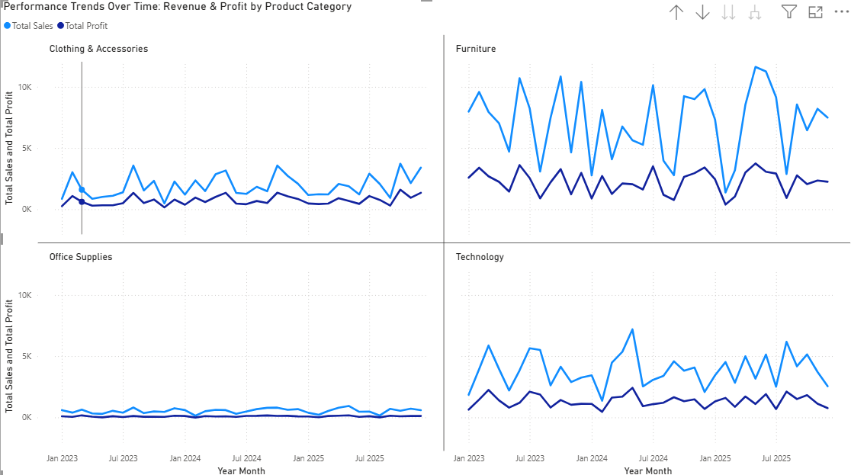
Key Findings
Sales are stable over the full period but fluctuate month to month, with stronger peaks during parts of Q2 and Q4. Revenue is heavily concentrated in Furniture, Technology, and the leading North American and European markets.
Business Insight
The business depends heavily on a relatively small number of categories, products, and countries. This concentration supports strong performance but also creates reliance on a limited set of revenue drivers.
Recommendation
Strengthen the strongest-performing categories and markets, while building growth in weaker regions and product areas to reduce concentration risk.

5. Profitability Analysis
Where is the business making or losing money?
Analysis
The business is profitable overall, but performance varies by category. Furniture generates the most profit ($81.2k), followed by Technology ($48.3k), while Clothing & Accessories has the highest margins despite lower sales. Office Supplies is the weakest category, contributing just 4.0% of sales and 2.1% of profit.
Top-performing products are mainly larger furniture and tech items, such as Ergonomic Office Chair and Standing Desk Converter. In contrast, low-value office items like Paper Clips and Highlighters contribute little or negative profit. There are also 272 loss-making orders, indicating some inefficiency despite overall profitability.
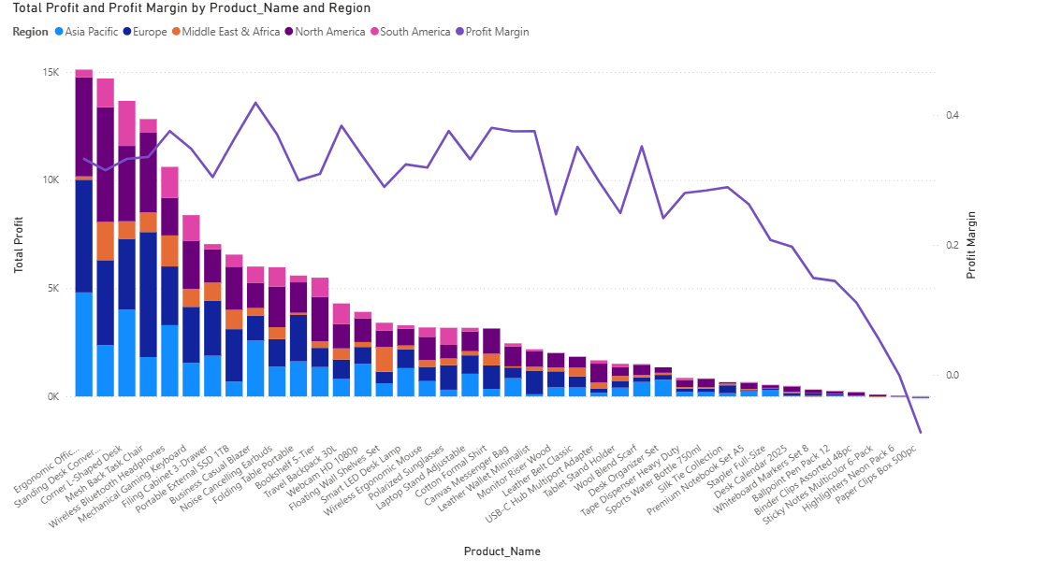Key Findings
High revenue does not always lead to strong profitability. Large furniture and technology products drive much of the profit, while low-value office products contribute weak margins and in some cases losses.
Business Insight
The strongest parts of the business are also relatively efficient, but weaker product groups are eroding profitability. This suggests that the business should focus less on low-value, low-margin items and more on the products that consistently convert revenue into profit.
Recommendation
Review pricing, discounting, and fulfilment strategy for weak-performing products, particularly in Office Supplies. Reduce emphasis on structurally low-margin or loss-making items where possible.

6. Customer Segmentation
Which customer segments are most valuable to the business?
Analysis
The Consumer segment is the largest and most valuable segment in the dataset. It generates 52.9% of total sales and 55.0% of total profit, while also producing the strongest profit margin among the three segments. Corporate is the second-largest segment by revenue but delivers the weakest margin, suggesting that these customers generate volume more than profitability. Home Office performs moderately in both sales and profit and is more efficient than Corporate on a margin basis.
This pattern indicates that growth is not equally valuable across segments. The Consumer segment combines scale with stronger profitability, while Corporate appears more dependent on lower-margin transactions.
Fig 5. Sales, Profit, and Profit Margin by Customer Segment.
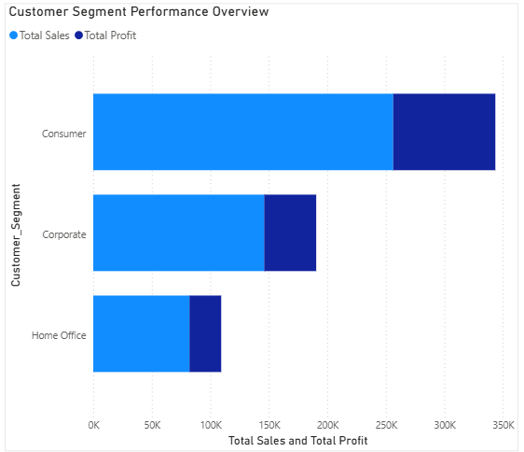
Key Findings
The Consumer segment is the most important segment for both sales and profit. Corporate generates substantial revenue but weaker margins.
Business Insight
Not all customer segments contribute equally to business quality. Some segments drive volume, while others create stronger profit efficiency.
Recommendation
Focus retention and growth efforts on high-margin customer groups, and review discount and pricing strategies for the Corporate segment to improve efficiency.
7. Regional and Market Analysis
Which markets are performing well, and which need attention?
Analysis
Regional performance is relatively balanced, with Europe, North America, and Asia Pacific all making significant contributions to both sales and profit. Europe leads in total sales at $137.0k, followed closely by North America at $133.9k and Asia Pacific at $121.7k. Profit follows a similar pattern.
Margin differences between regions are not extreme, but some variation remains. North America records the strongest profit margin, followed closely by Europe, while Middle East & Africa has the weakest regional margin. At country level, the top revenue markets are Mexico, Canada, United States, Japan, and United Kingdom.
Overall, the leading markets are strong in both scale and profitability, but smaller regional differences suggest that fulfilment costs and product mix may be affecting margins in weaker-performing areas.
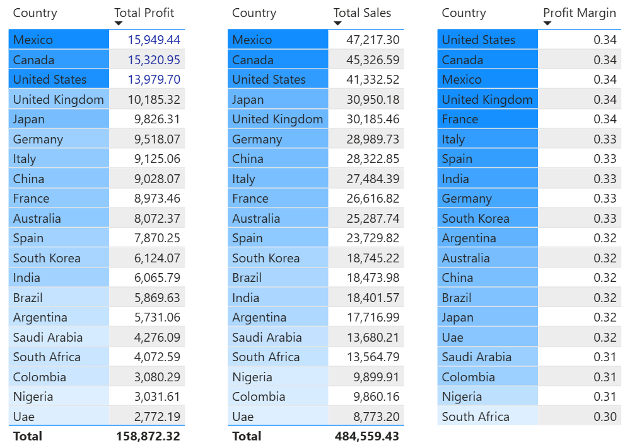
Key Findings
The strongest regional markets are Europe, North America, and Asia Pacific. Mexico, Canada, and the United States are the leading countries by revenue.
Business Insight
The business performs well across several major markets rather than relying on a single region, but some margin differences suggest opportunities for regional optimisation.
Recommendation
Improve pricing, fulfilment efficiency, or product mix in weaker-margin regions while continuing to support the strongest-performing countries.

8. Discount Strategy Analysis
Are discounts helping or hurting profitability?
Analysis
Discounting appears to weaken profit more than it supports sales. Orders in the 0–10% discount range generate the highest average sales and the highest average profit. Profit declines sharply as discount levels increase. Orders discounted between 20–30% still generate revenue, but they produce much lower profit than lightly discounted orders.
This pattern suggests that discounting is not being offset by sufficient sales uplift. Deeper discounts may support order conversion or volume in some cases, but they reduce profitability at the order level and contribute to margin pressure overall.
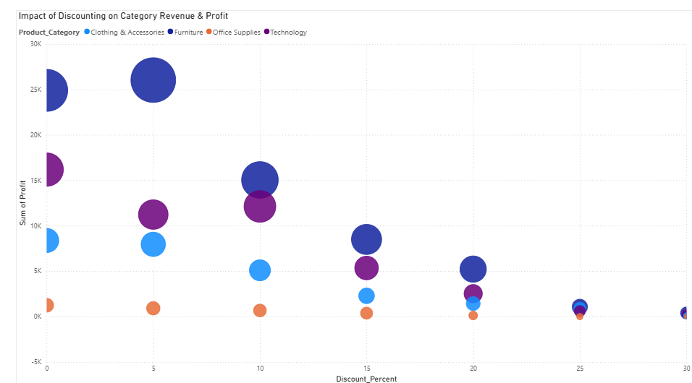

Key Findings
Orders with deeper discounts are significantly less profitable, and discounts above 20% are associated with much weaker returns.
Business Insight
Heavy discounting is reducing margin quality. While discounts may still help drive demand, they are not producing enough value to justify the loss in profit at higher levels.
Recommendation
Apply discounts more selectively, cap aggressive discount levels where possible, and move away from broad discounting strategies that reduce profit without enough revenue benefit.

9. Shipping Cost Optimisation
How do shipping costs affect profitability?
Analysis
Shipping cost is a major factor in margin performance, especially when viewed relative to order value. While larger orders can absorb higher shipping costs more effectively, profitability deteriorates sharply when shipping takes up too much of total sales. This is particularly visible in low-value orders, where shipping cost becomes a disproportionate burden and pushes margins down.
The strongest evidence of this issue appears in the shipping cost ratio analysis, which shows a very strong negative relationship between shipping intensity and profit margin. This supports the wider finding that low-value, shipping-heavy transactions are among the least efficient parts of the business.
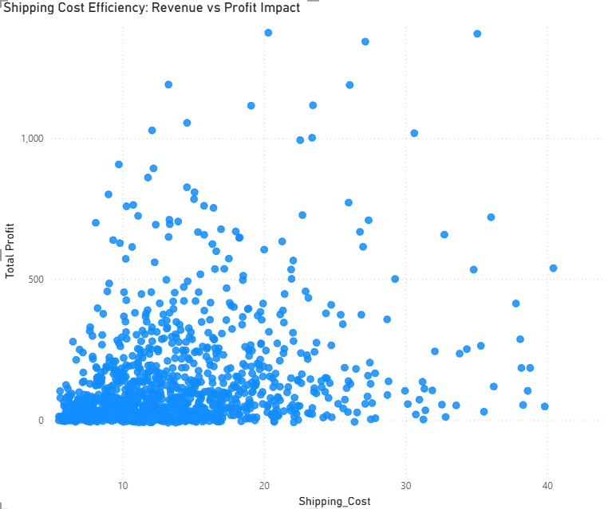
Key Findings
High shipping cost ratios are strongly associated with weak margins. Shipping is especially damaging on lower-value orders.
Business Insight
Shipping is not simply a cost issue; it is a structural profitability issue in parts of the order mix. Smaller orders and low-value products appear most exposed.
Recommendation
Introduce minimum order thresholds, review shipping pricing policies, and explore fulfilment changes that reduce shipping burden on low-value transactions.
10. Payment Method Analysis
Do payment methods influence customer behaviour or value?
Analysis
Credit Card is the dominant payment method, accounting for the largest share of both sales and orders, followed by Paypal. Cash On Delivery and Bank Transfer represent smaller shares of activity. Profitability is relatively similar across payment methods, with only small differences in margin.
This suggests that payment method is more useful as an indicator of customer preference than as a major driver of business performance.
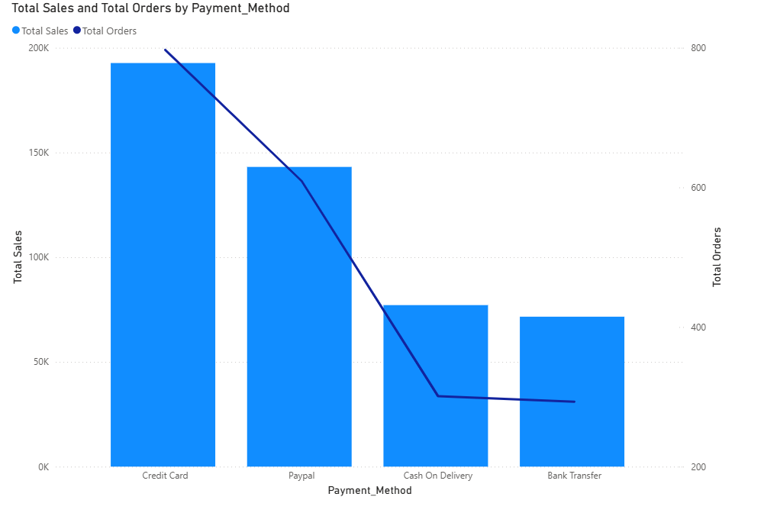
Key Findings
Credit Card and Paypal dominate transaction activity, while profit margins remain broadly similar across payment methods.
Business Insight
Payment method appears to reflect customer behaviour more than profitability differences.
Recommendation
Continue supporting the most widely used payment methods and use payment data primarily to understand customer preferences rather than as a core profit lever.

11. Conclusion
The business is profitable and relatively stable over time, but performance is concentrated in a limited set of categories, products, and markets. Furniture and Technology are the primary drivers of both revenue and profit, while Consumer customers are the most valuable segment. The strongest-performing products are larger-ticket furniture and technology items, which contribute heavily to overall business success.
At the same time, there are clear sources of margin pressure. Office Supplies is the weakest category, many lower-value products generate very limited profit, and 272 orders are loss-making. Discounting and shipping efficiency are the two main operational issues identified in the analysis. Deep discounts reduce profit substantially, and high shipping cost ratios are strongly associated with low margins.
Overall, the findings suggest that future improvement should focus on protecting the strongest-performing categories and products, tightening discount strategy, reducing shipping inefficiency on low-value orders, and reviewing weak-performing products and markets more closely.

